**Assignment 3**

Go to instances in the AWS dashboard click on the instance and go to security tab below

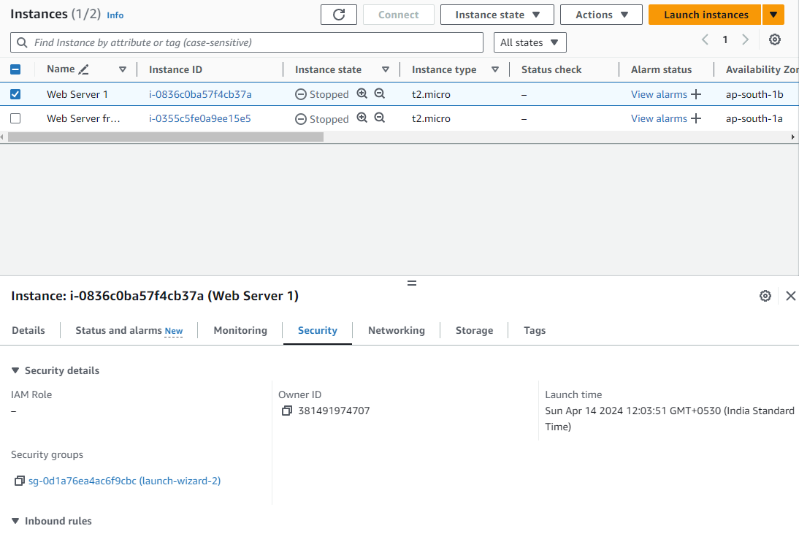

Click on the link under security groups

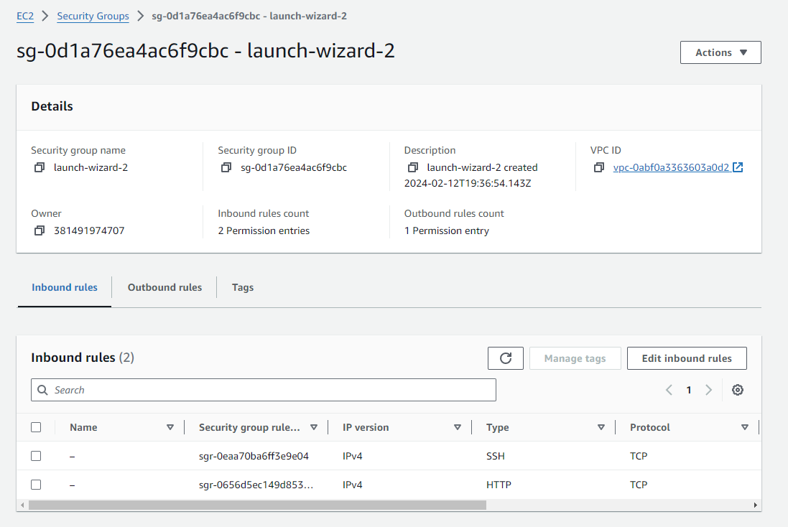

From here click on edit inbound rules to add/edit the inbound rules from where requests will get accepted

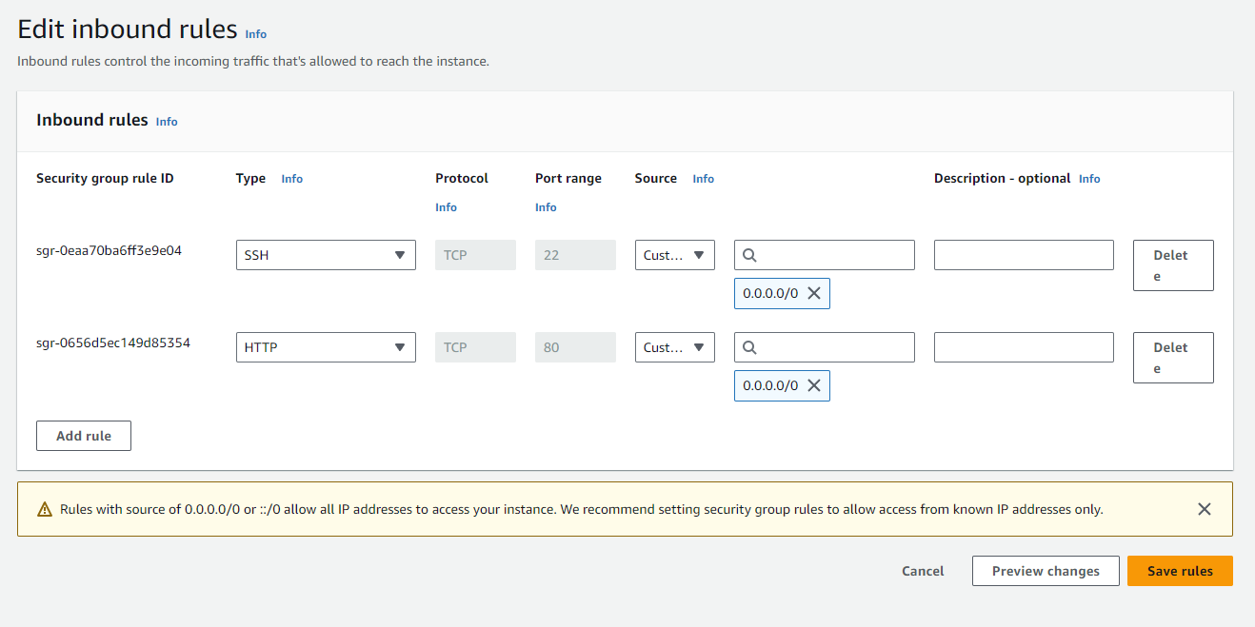

Now we can connect to that server using SSH

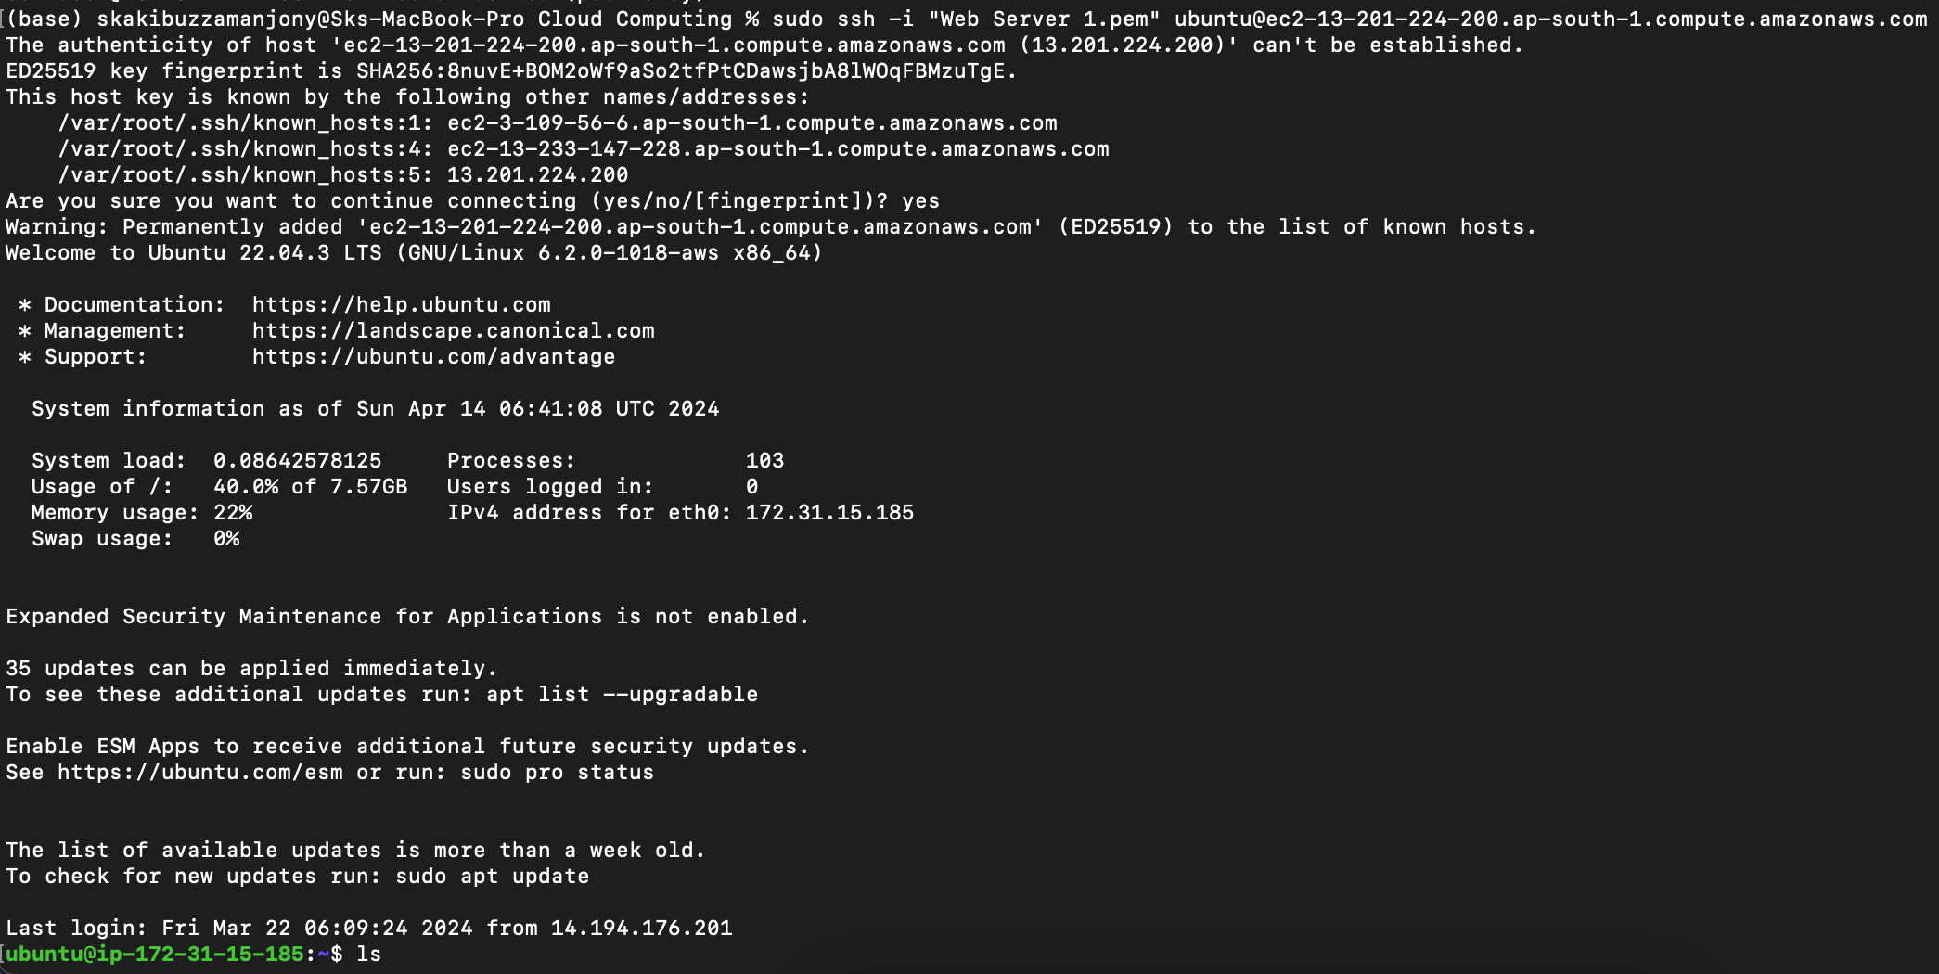

Also send HTTP request to see the webpages

